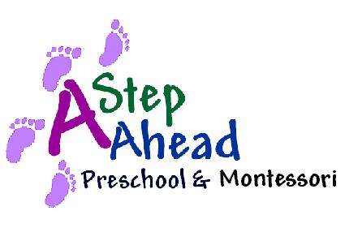Please read and initial the following brief policy statements

____If your child is going to be absent for the day, please inform the school in your earliest convenience.

____We require 30-day written notification to dis-enroll from our community school’s programs.

____If a holiday falls on a weekend, it will be observed on the preceding Friday or the Monday following.

___ All Students of A Step Ahead Preschool & Montessori MUST submit their tuition fees for the schedule in which they are enrolled regardless of attending the school, unless student’s circumstances discussed with the school’s administration.

____Yearly material fee of $250.00 is due upon enrollment (excluding infants), then billed annually upon student’s anniversary. All material fees are Non-refundable.

____All fees are due and MUST BE PAID IN ADVANCE by Monday. Payments are considered past due at close on Tuesday and a late charge of $25.00 will be assessed at that time. Enrollment is subject to termination when payment for two weeks become delinquent.

____All students must be enrolled in the automated payment delivery method (ACH). For more information please view the attached form.

____Children must be kept at home if they exhibit any of the following symptoms: fever, undiagnosed rash or sore, pink or red eyes, discharge from the eyes or ears, a persistent cough, vomiting or diarrhea, and/or any symptom of a communicable illness.

_____Prescribed medication will be administered only with the proper medical authorization completed and signed. All medication MUST be given to the office, where it is kept in a locked container. No medication is to be in a child’s suitcase, backpack, and/or diaper bag. ALL medication MUST be labeled with the child's first and last name and be in the original container.

_____If you bring over an OTC medication, it MUST be accompanied by a Doctor’s note that’s dated (must be a time frame stated on Doctor’s note – cannot say as needed) and state why child is on this medication.

_____For the B. D. party events, we give parent an option to bring food items to share. Food must be store-bought and wrapped; “Home-made” may come into the center for our students, approved by our director. We love birthdays, though. We are happy to help celebrate your child’s birthday. You could supply a healthy snack to share with your child’s class. If your schedule permits, you are welcome to join us.

___We encourage our parents to have their children worn tennis shoes or sneakers rather than flip-flops for their convenience and safety.

