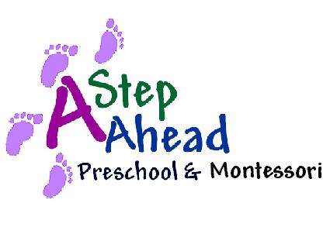August 01, 2019
Subject: Automated Tuition Payment
Respectful Parents,
We are currently considering implementing an Automated Direct Debit feature to service our students’ tuition fees. This service is offered versus having to send your payments via U.S. mail, manually issue checks each month, or utilize your credit cards. With Bank of America/Merrill Lynch’s Direct Debit service, our school will directly debit your account at virtually any bank, savings and loan, or credit union in the United States on the designated debit date established for your child’s tuition schedule.
Although this added feature to our school’s payment system will be completely voluntary, it will provide the school’s administration considerable savings on banking fees. This program will be launched as early as Sep 08 as an alternative free payment option for those parents, who will complete the form and return it to my attention. Also, for parents, who continue to use our automated teller machine after October 1st, there will be 3.00% processing fee added to their children’s tuition fee schedules. This new fee guideline is brought in response to high cost of using such payment services.
We sincerely value your time and support in helping us provide your precious children with most efficient ways to manage their school. Please let us know, if you have any questions or concerns. Thank you.
Warmest regards,
Aram Sayadi
Head of School

Parent’s Name: ____________________________________________________

Parent Account Number: ________________________________________

Parent ACH Routing Number: ____________________________________

